Festival Of The Dead

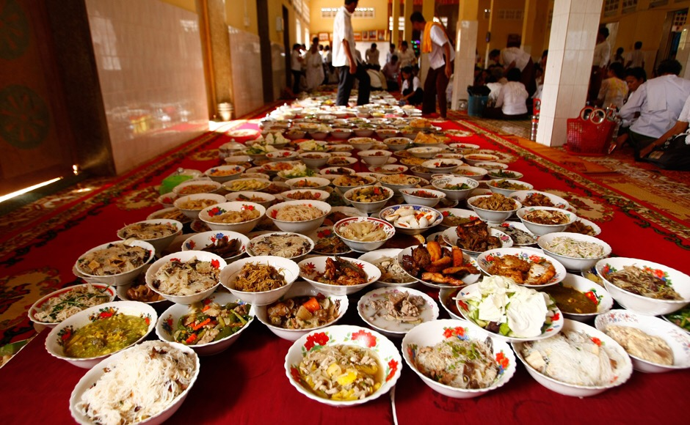

The 15-day ceremony of Pchum Ben is a time for Cambodians to honor their previous seven generations of ancestors.

The first 14 days are known as “Kan Ben” and during this time families gather at nearby pagodas, offering food and prayers to their ancestors to save them from bad karma. The belief is that deceased relatives wait at the pagodas for their loved ones to return to them.

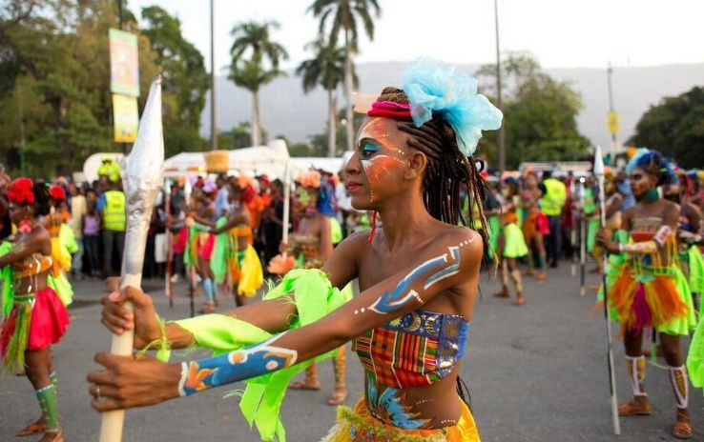

“Ben Thom” on Day 15 sees families bring baskets full of flowers and children offering sticky rice cake to the monks. This is the main festival day and everyone dresses up for the occasion. Cambodians believe their actions on earth shape their appearance as a ghost after death. By praying and offering food during Pchum Ben, the family is helping their ancestors pass on to a better life as well as ensuring their ancestors don’t get angry and curse them.

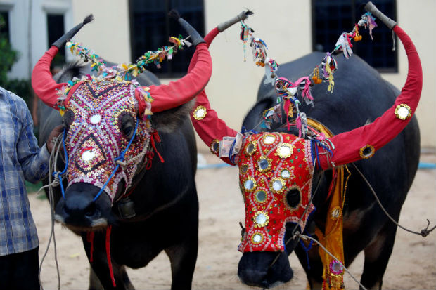

Pchum Ben means “to gather together a ball of food” and this day, also known as the “Hungry Ghosts Festival” and “Festival Of The Dead” is the day when the Cambodians pay respect to all their 7 generations of ancestors. It is believed that on the first day of this festival, the gates of the hell are opened and all the ghosts are let out, some of them being ancestors to the people.

The celebration involves a food offering ritual in the pagodas with the expectation that the merits earned by offering food to the monks will reduce the sins of the ancestors. This is a popular festival in Cambodia.

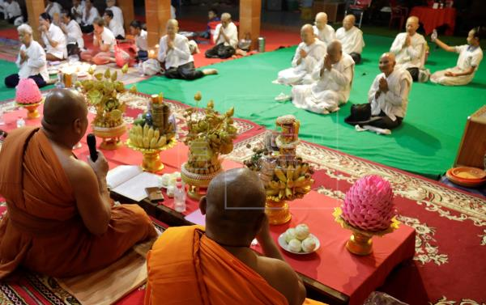

The festival dates back to the Middle Ages and is among the most important holidays in Cambodia. Nowadays students and workers will return back to their families to observe Pchum Ben with them and make their offerings.

**When:**16th September 2020